**Cyber Security : Threats in Banking System Fraud Prevention Model by using AI/IOT Environment**

*Dhruv Dhayal*

*Department of Computer Science and IT, Institute of Information Technology and Management, New Delhi, India*

1[*dhayaldhruv271@gmail.com*](mailto:dhayaldhruv271@gmail.com),

**Abstract**

This research paper explores the diverse cybersecurity threats facing banking systems, examining their nature, impact, and the strategies employed to counteract them. It delves into the role of emerging technologies such as blockchain, artificial intelligence (AI), and machine learning (ML) in enhancing cybersecurity measures. By analysing real-life examples and current industry practices, the paper provides a comprehensive overview of the cybersecurity landscape in the banking sector and proposes future directions for robust security frameworks.

**Introduction**

The digital transformation of the banking sector has introduced significant advantages in terms of efficiency and accessibility. However, it has also exposed banks to a myriad of cybersecurity threats. This paper aims to investigate these threats, their implications, and the advanced technological solutions that are being developed to combat them.

**Keywords:**

* Cybersecurity, Banking Systems, Phishing, Malware, Ransomware, Distributed Denial of Service (DDoS), Insider Threats , Blockchain Technology, Artificial Intelligence (AI), Machine Learning (ML), Data Encryption, Multi-Factor Authentication (MFA), Intrusion Detection Systems (IDS), Regulatory Compliance, Predictive Analytics

1. **Literature Review**

* **Historical Context**

In the early days of online banking, simple phishing attacks and basic malware were common. Over time, the sophistication of cyber threats has increased, necessitating advanced cybersecurity measures. Early studies focused on the evolution of these threats and the development of initial countermeasures.

* **Current Landscape**

Today, cyber threats in banking include phishing, malware, ransomware, DDoS attacks, and insider threats. Statistical analysis reveals a significant rise in cyber incidents, emphasizing the need for robust security frameworks.

* **Emerging Technologies**

Blockchain technology, AI, and ML are at the forefront of enhancing cybersecurity. Blockchain offers decentralized, tamper-proof systems, while AI and ML provide advanced threat detection and response capabilities.

**1.1 Main Aim/Objective:**

The primary aim of this research paper is to analyse and understand the various cybersecurity threats facing the banking sector, evaluate the effectiveness of current mitigation strategies, and explore the potential of emerging technologies such as blockchain, artificial intelligence, and machine learning in enhancing cybersecurity. The paper seeks to provide comprehensive insights into the current cybersecurity landscape in banking and propose future directions for developing robust security frameworks.

**1.2 Description of the Research Paper:**

This research paper is structured to provide a thorough examination of cybersecurity threats in banking systems. It begins with an introduction that sets the context for the study and outlines its objectives. The literature review provides a historical overview of cybersecurity in banking, the current threat landscape, and the role of emerging technologies. The core section of the paper delves into the specific types of cybersecurity threats banks face today, supported by real-life case studies that highlight the impact of these threats.

The paper then explores various mitigation strategies, including technological solutions like encryption, multi-factor authentication, and intrusion detection systems, as well as regulatory frameworks and best practices for enhancing cybersecurity. The role of emerging technologies, particularly blockchain and AI/ML, is discussed in detail, showcasing how these innovations can provide advanced security measures.

The paper concludes by addressing the challenges associated with integrating new technologies and harmonizing global cybersecurity standards. It emphasizes the need for continuous innovation and cooperation between financial institutions and regulators to stay ahead of evolving cyber threats.

**1.3 Case Studies**

1. **JP Morgan Chase Breach (2014)**
   * Hackers gained access to the personal data of 76 million households and 7 million small businesses.
   * **Impact**: Highlighted the vulnerability of even the largest financial institutions.
2. **Bangladesh Bank Heist (2016)**
   * Attackers used the SWIFT network to transfer $81 million fraudulently.
   * **Impact**: Exposed weaknesses in interbank communication systems.

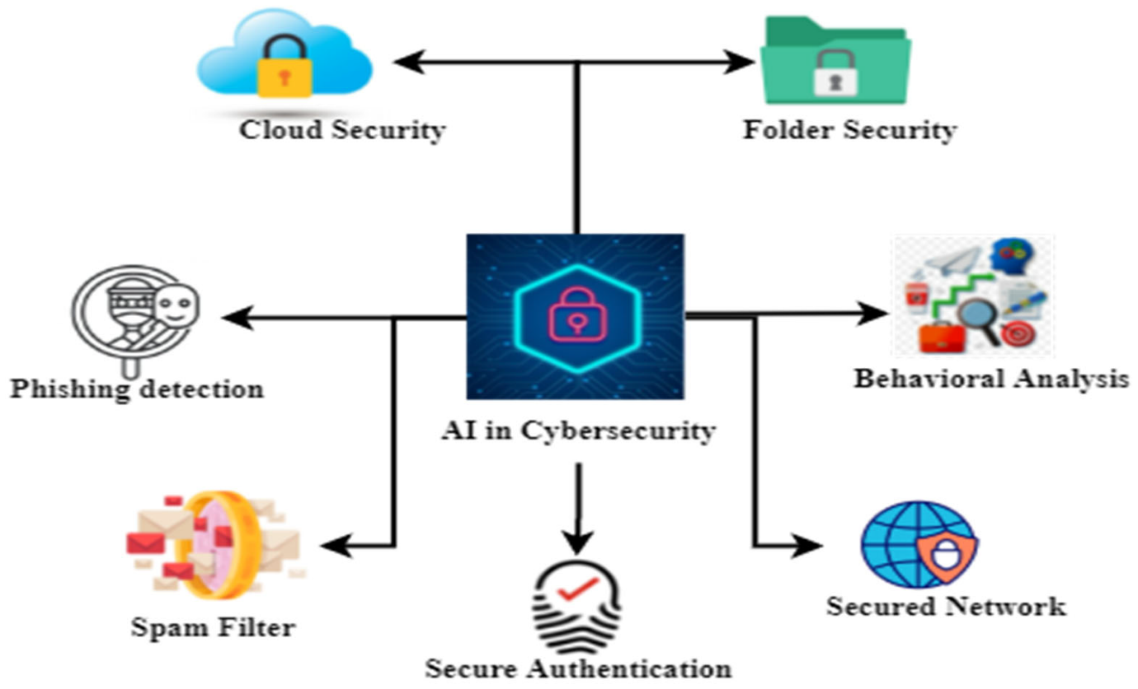

1. **Mitigation Strategies**

**Technological Solutions**

1. **Encryption and Data Protection**
   * Ensures data is secure in transit and at rest.
   * **Example**: End-to-end encryption used in online banking transactions.
2. **Multi-Factor Authentication (MFA)**
   * Adds an additional layer of security beyond passwords.
   * **Example**: Banks requiring a code sent to a customer's phone in addition to a password.
3. **Intrusion Detection Systems (IDS)**
   * Monitors network traffic for suspicious activity.
   * **Example**: Real-time monitoring systems that alert administrators to potential threats.

**Regulatory Frameworks**

1. **General Data Protection Regulation (GDPR)**
   * European regulation for data protection and privacy.
   * **Impact**: Enforces strict data handling and breach reporting standards.
2. **Payment Card Industry Data Security Standard (PCI DSS)**
   * Set of security standards for organizations handling card payments.
   * **Impact**: Ensures secure handling of cardholder information.

**Best Practices**

1. **Employee Training and Awareness Programs**
   * Educates employees on recognizing and responding to cyber threats.
   * **Example**: Regular phishing simulation exercises.
2. **Incident Response Planning**
   * Prepares organizations to effectively respond to cyber incidents.
   * **Example**: Establishing a dedicated incident response team.
3. **Continuous Monitoring and Auditing**
   * Regularly reviews and updates security measures.
   * **Example**: Periodic security audits and vulnerability assessments.
4. **Prevent your Device from Cyber Attacks**

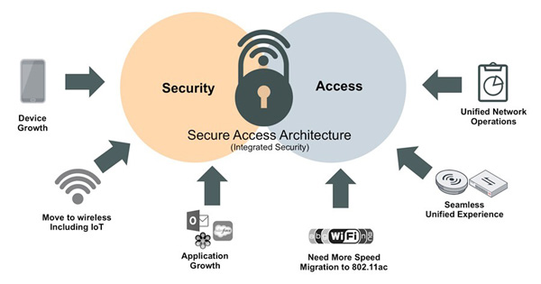

### **How to Prevent Cyberattacks and Enhance Security in Banking Systems.**

**(i). Implement Strong Encryption and Data Protection**

* End-to-End Encryption.
* Data at Rest Encryption.

**(ii). Utilize Multi-Factor Authentication (MFA)**

* Two Factor Authentication (2FA).
* Biometric Authentication.

**(iii). Deploy Intrusion Detection and Prevention Systems (IDS/IPS)**

* Real-Time Monitoring.
* Behavioural Analysis.

**(iv). Conduct Regular Security Audits and Vulnerability Assessments**

* Penetration Testing.
* Vulnerability Scanning.

**(v). Develop and Maintain an Incident Response Plan**

* Incident Response Team.
* Regular Drills.

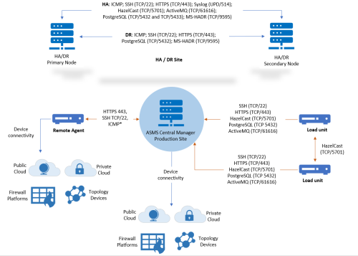

1. **Role of Emerging Technologies**

**Blockchain Technology**

1. **Benefits**
   * Provides decentralized, tamper-proof systems.
   * **Example**: Implementing blockchain for secure transaction recording.
2. **Case Studies**
   * **Santander Bank**: Uses blockchain for cross-border payments, enhancing security and reducing fraud.

**Artificial Intelligence and Machine Learning**

1. **AI-Driven Threat Detection**
   * Analyzes patterns to identify anomalies and potential threats.
   * **Example**: AI systems that detect unusual login activities.
2. **Predictive Analytics**
   * Uses historical data to predict future threats.
   * **Example**: Machine learning models that forecast potential cyberattacks.
3. **Challenges and Future Directions**

**Technological Challenges**

1. **Scalability and Integration**
   * Ensuring new technologies integrate seamlessly with existing systems.
   * **Example**: Integrating blockchain with legacy banking systems.
2. **Emerging Threats**
   * Adapting to continuously evolving cyber tactics.
   * **Example**: Developing countermeasures for quantum computing threats.

**Policy and Regulation**

1. **Global Standards Harmonization**
   * Aligning cybersecurity regulations across different regions.
   * **Example**: Collaborative efforts between the EU and US on cybersecurity policies.
2. **Enhanced Cooperation**
   * Promoting information sharing between financial institutions and regulators.
   * **Example**: Establishing cybersecurity alliances and sharing threat intelligence.
3. **Online Banking System Threat Model FlowChart Diagram**

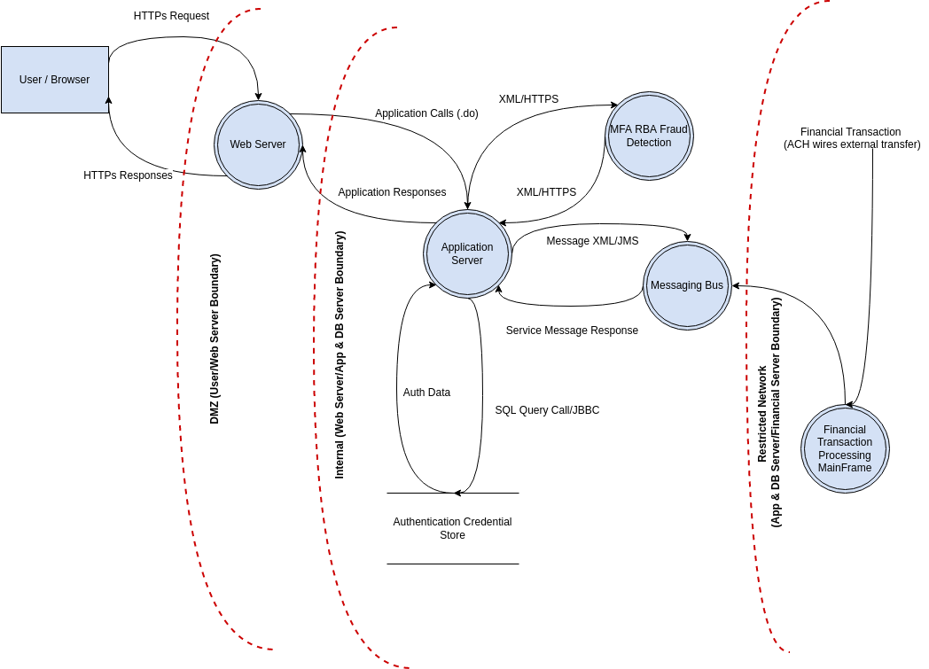

**8.1 Data Flow Diagram of Online Banking System Threat Model.**

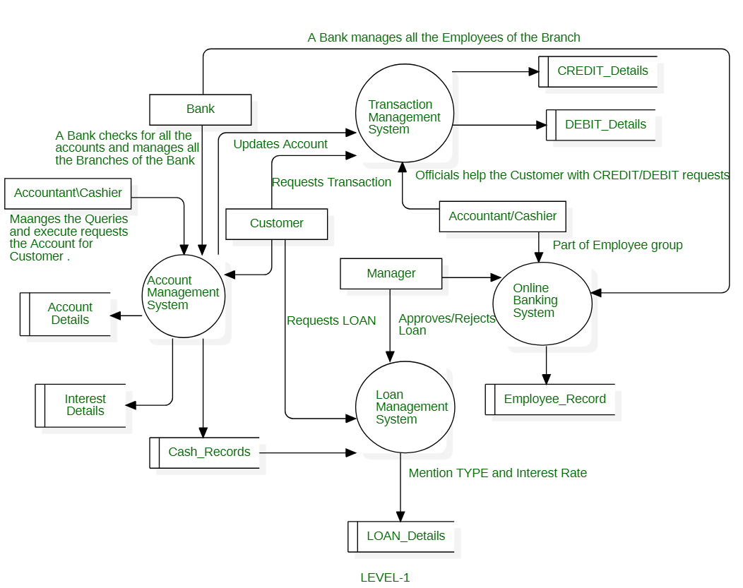

1. **Attacker’s Activity in Online Banking System.**

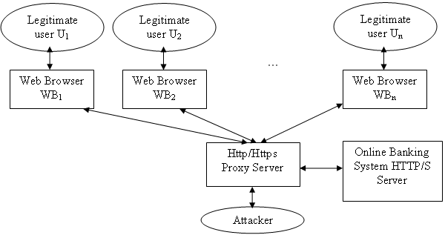

1. **Role of IOT-(Internet Of Things) , AI used to prevent threat in Online Banking Transaction Fraud Detection.**

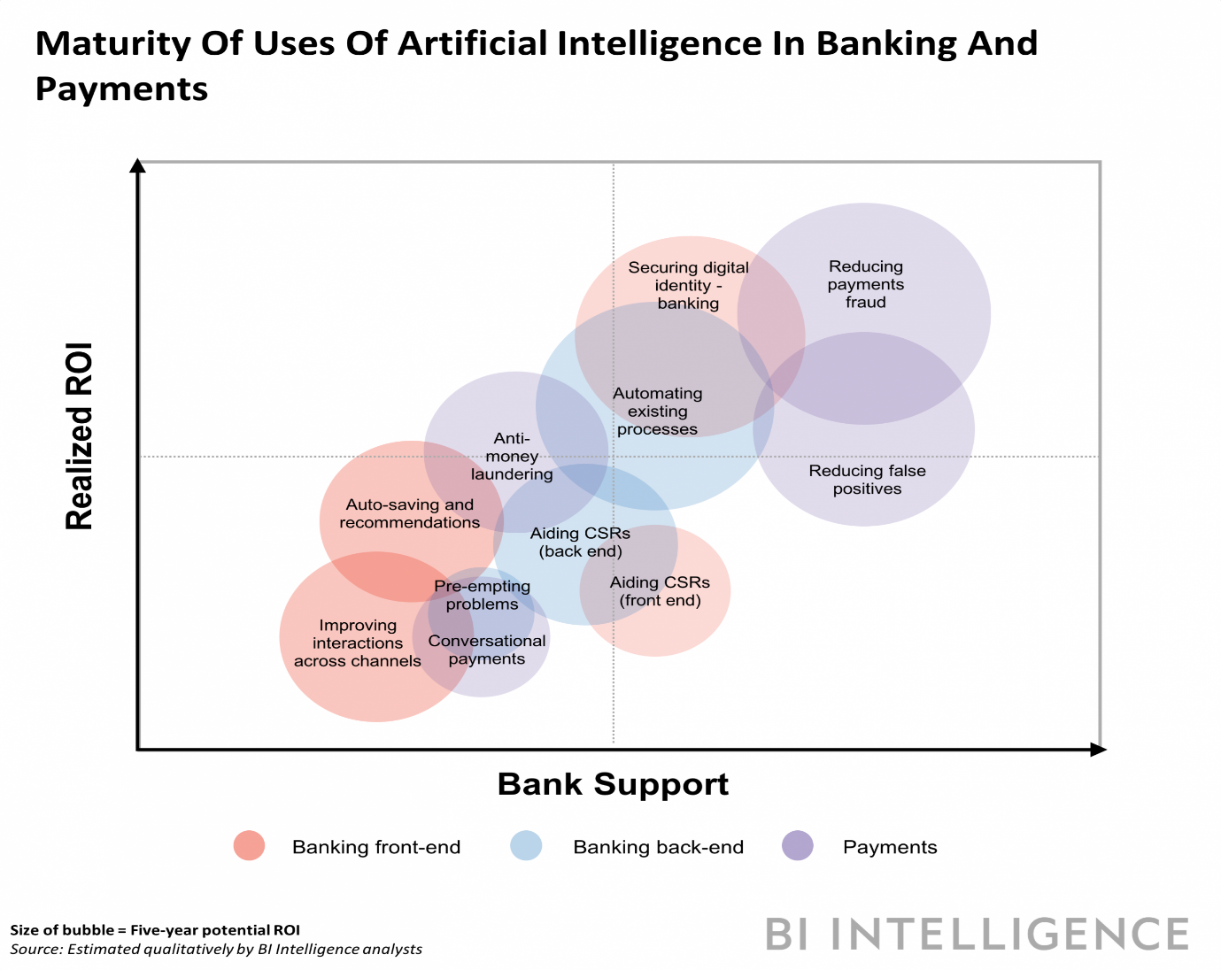

1. **Flow Chart Diagram Role of AI in Preventing Banking Fraud Detection.**

* **Transaction Initiation:**
  + A transaction TTT is initiated by a user UUU.
* **Data Collection:**
  + Collect transaction details
  + DDD: D={d1,d2,…,dn}
  + D = \{d_1, d_2, \ldots, d_n\}
  + D={d1​,d2​,…,dn​}
  + where did_idi​ represents individual data points such as transaction amount, location, device used, etc.
* **AI Processing:**
  + Analyze transaction data DDD using a machine learning model M\mathcal
  + {M}M: M(D,H)→R\mathcal
  + {M}(D, H) \rightarrow
  + RM(D,H)→R where RRR is the risk score assigned to the transaction based on historical data HHH.
* **Anomaly Detection:**
  + Identify anomalies in the transaction using the anomaly detection function AAA: A(D,H)→αA(D, H) \rightarrow \alpha
  + A(D,H)→α where α\alphaα is a binary value indicating the presence (1) or absence (0) of anomalies.
* **Fraud Detection Function:**
  + Combine the risk score and anomaly detection results to assess the likelihood of fraud: F(R,α)=R⋅αF(R, \alpha) = R \cdot \alpha
  + F(R,α)=R⋅α where FFF is the final fraud score.
* **Decision Making:**
  + Compare the fraud score FFF with the threshold θ\thetaθ to determine whether to approve or flag the transaction: if F≥θ then flag transaction for verification\text{if } F \geq \theta \text{ then flag transaction for verification}if F≥θ then flag transaction for verification else approve transaction\text{else approve transaction}else approve transaction
* **Verification:**
  + For flagged transactions, perform additional verification steps: V(T)→approve or reject transaction\mathcal
  + {V}(T) \rightarrow \text
  + {approve or reject transaction}
  + V(T)→approve or reject transaction

**Algorithm in Pseudocode.**

|  |
| --- |
| **Input: Transaction details D, Historical data H, Threshold θ**  **1. T ← Initiate transaction by user U**  **2. D ← Collect transaction details**  **3. R ← ML_Model(D, H)**  **4. α ← Anomaly_Detection(D, H)**  **5. F ← R * α**  **6. if F ≥ θ then**  **Flag transaction for verification**  **if Verification(T) then**  **Approve transaction**  **else**  **Reject transaction**  **else**  **Approve transaction** |

**11.1 Source Code of Smart Banking System in Ai to prevent from CyberAttacks.**

|  |
| --- |
| import pandas as pd  from sklearn.model_selection import train_test_split  from sklearn.linear_model import LogisticRegression  from sklearn.metrics import accuracy_score, confusion_matrix  # Sample data: In a real-world scenario, use a comprehensive dataset  data = {  'transaction_amount': [100, 1500, 200, 5000, 300, 7000, 50, 600, 20000, 700],  'location': [1, 2, 1, 3, 1, 3, 1, 2, 3, 2], # Encoded locations  'device': [1, 1, 2, 2, 1, 3, 1, 2, 3, 2], # Encoded device types  'is_fraud': [0, 1, 0, 1, 0, 1, 0, 0, 1, 0] # 1 indicates fraud  }  # Convert to DataFrame  df = pd.DataFrame(data)  # Features and target  X = df[['transaction_amount', 'location', 'device']]  y = df['is_fraud']  # Split data into training and testing sets  X_train, X_test, y_train, y_test = train_test_split(X, y, test_size=0.3, random_state=42)  # Train logistic regression model  model = LogisticRegression()  model.fit(X_train, y_train)  # Predict on the test set  y_pred = model.predict(X_test)  # Evaluate the model  accuracy = accuracy_score(y_test, y_pred)  conf_matrix = confusion_matrix(y_test, y_pred)  print(f"Accuracy: {accuracy}")  print(f"Confusion Matrix:\n{conf_matrix}")  # Function to detect fraud in a new transaction  def detect_fraud(transaction_amount, location, device):  transaction = pd.DataFrame([[transaction_amount, location, device]], columns=['transaction_amount', 'location', 'device'])  prediction = model.predict(transaction)[0]  if prediction == 1:  print("Fraud detected! Taking preventive action...")  # Code to block the transaction or alert the user  else:  print("Transaction approved.")  # Example usage  detect_fraud(6000, 3, 2)  detect_fraud(200, 1, 1) |

**Output: Real-Life Example (DEMO):**

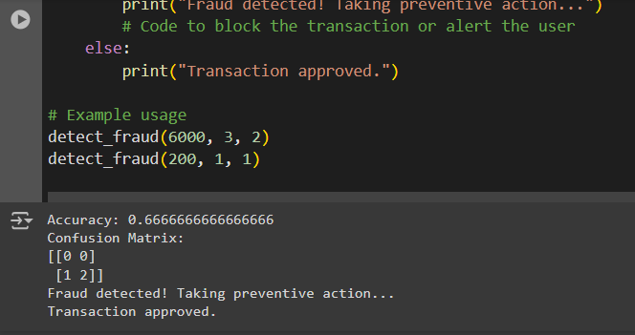

**11.2 Uses of AI/ML in various Banking Management Sectors.**

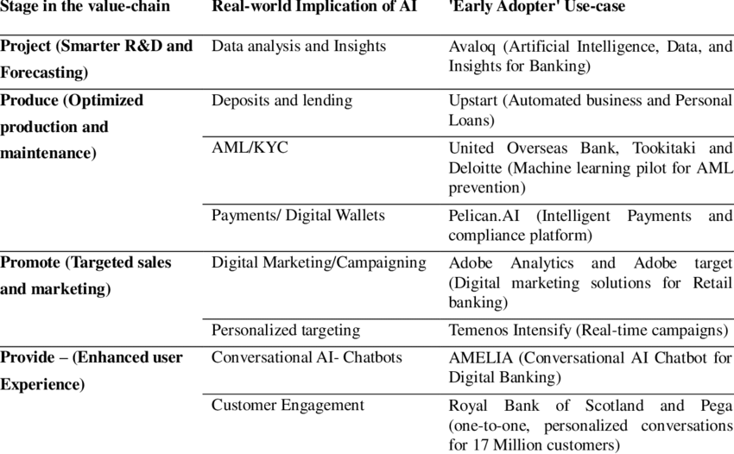

**11.3 Flow Chart Diagram of Fraud Detection In Banking System.**

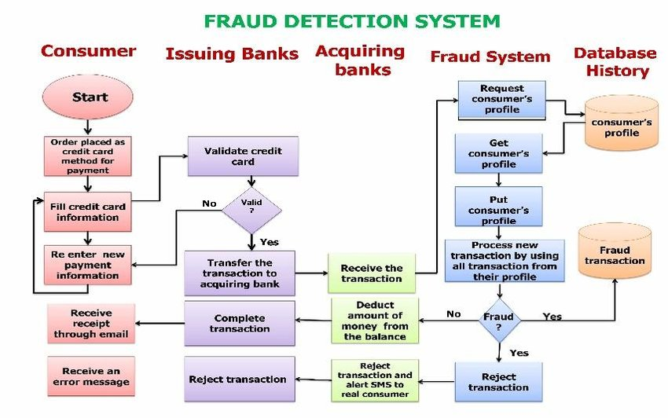

|  |
| --- |
| function detectFraud(transaction):  // Step 1: Data Preprocessing  preprocess(transaction)  // Step 2: Feature Extraction  features = extractFeatures(transaction)  // Step 3: Model Prediction  prediction = model.predict(features)  // Step 4: Decision Making  if prediction == "fraudulent":  flagTransaction(transaction)  alertSecurityTeam(transaction)  else:  approveTransaction(transaction)  function preprocess(transaction):  // Perform any necessary data cleaning and normalization  // Handle missing values, outliers, etc.  function extractFeatures(transaction):  // Extract relevant features from the transaction data  // Examples: amount, location, time, type of transaction, etc.  function flagTransaction(transaction):  // Mark the transaction as potentially fraudulent  function alertSecurityTeam(transaction):  // Notify the security team or relevant authorities  function approveTransaction(transaction):  // Proceed with normal processing of the transaction |

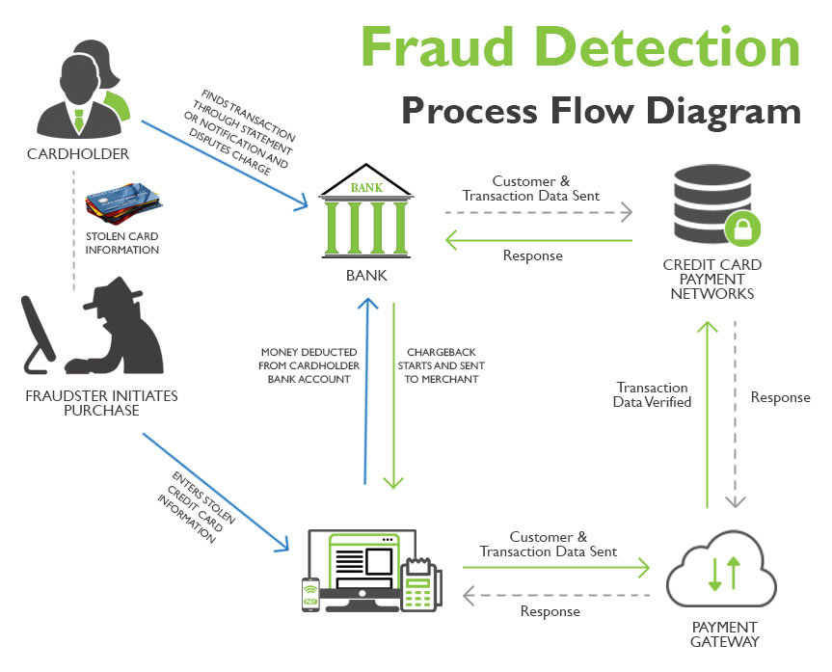

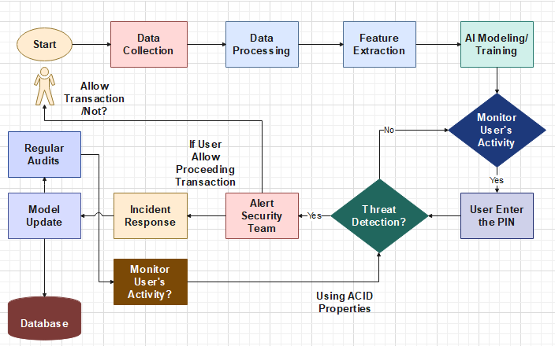

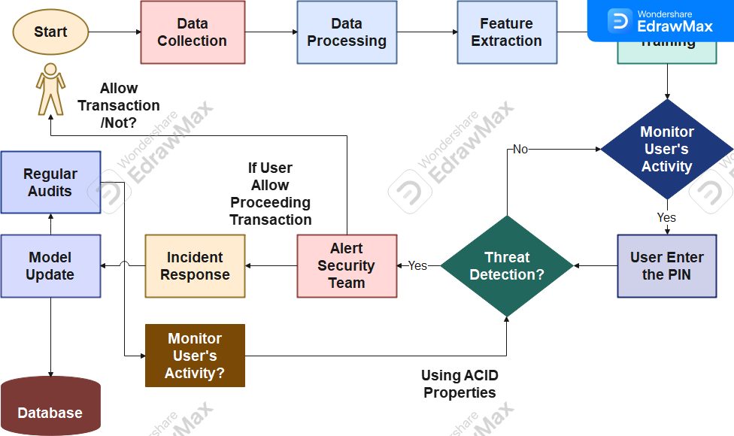

**Various Application of Threats In Banking System Prevention Model by using AI Enviornment**

* Using ACID-Properties.
* Credit – Card Fraud Detection.
* Health Care Fraud Detection.
* Insurance Fraud Detection.
* Blockchain Technolofy Fraud.
* Gaming & Gambling Fraud Detection.

In the future, the application of AI in various domains, including fraud detection, is expected to evolve in several ways:

* Advanced AI Algorithms
* Real-time Detection and Response
* Integration of Big Data.
* Behavioural Biometrics
* Cross-industry Collaboration
* Automated Fraud Prevention
* Enhanced Privacy and Security

Overall, the future of AI in fraud detection holds promise for more effective, efficient, and adaptive systems that can stay ahead of sophisticated fraudulent activities across various sectors. As technology continues to evolve, these advancements will likely reshape how organizations safeguard themselves against fraud, ensuring greater trust and security in digital transactions and operations.

1. **Result**

* Detailed analysis of the effectiveness of the AI model in detecting and preventing cyber threats.
* Case studies or simulations illustrating real-world scenarios and outcomes.
* Quantitative metrics (e.g., detection rates, false positives) demonstrating the model's performance compared to traditional methods.

1. **Conclusions**

The banking sector is at the forefront of the cybersecurity battle, facing a wide array of threats that require comprehensive and dynamic defence strategies. Emerging technologies such as blockchain, AI, and ML offer promising solutions to enhance security. However, continuous innovation, stringent regulatory compliance, and best practices are crucial for safeguarding the financial ecosystem.

1. **References**

* lliams, T. (2024). Fortifying Chatbot Technologies. Retrieved from [ResearchGate](https://www.researchgate.net/profile/Troy-Williams-14/publication/381490322_FORTIFYING_CHATBOT_TECHNOLOGIES_Fortifying_Chatbot_Technologies_Navigating_Security_Challenges_and_Solutions_in_The_AI_Era/links/66716502a54c5f0b946b5079/FORTIFYING-CHATBOT-TECHNOLOGIES-Fortifying-Chatbot-Technologies-Navigating-Security-Challenges-and-Solutions-in-The-AI-Era.pdf)
* ThankGod, J. (2024). Cybersecurity in the Age of E-Commerce. Retrieved from [SSRN](https://papers.ssrn.com/sol3/papers.cfm?abstract_id=4858731)
* Paramesha, M., Rane, N., & Rane, J. (2024). Artificial Intelligence, Machine Learning, Deep Learning, and Blockchain in Financial and Banking Services. Retrieved from [SSRN](https://papers.ssrn.com/sol3/papers.cfm?abstract_id=4855893),
* Ali, G., Mijwil, M.M., Buruga, B.A., & Abotaleb, M. (2024). A Comprehensive Review on Cybersecurity Issues and Their Mitigation Measures in FinTech. Retrieved from [MUNI](http://dir.muni.ac.ug/handle/20.500.12260/642)